

**IS480 IS Application Project**

**Project Proposal**

**LeGIT**

**6th June 2017**

**Team Members:**

* Tee Yu Xuan (yuxuan.tee.2014@sis. smu.edu.sg) – Project Manager
* Chen Huiyan (huiyan.chen.2015@sis.smu.edu.sg) – Lead Frontend Developer
* Poedjiono Clarissa (clarissap.2015@sis.smu.edu.sg) – Lead Full Stack Developer
* Jeremy Bachtiar (jbachtiar.2015@sis.smu.edu.sg) – Lead Backend Developer
* Sheryl Chong Man Er (mechong.2015@sis.smu.edu.sg) – Lead Quality Assurance
* Ong Yi Xuan (yixuan.ong.2015@sis.smu.edu.sg) –  Deputy Project Manager and Backend Developer

**Faculty Supervisor:**

* Professor Benjamin Gan

**Sponsor Information:**

Organization: Grand Canyon Pte Ltd

Business Description: Premium linen manufacturer and retailer

Department: Business Development

* Xia Ming (michael.xia@highlanderlondon.com) – General Manager

**Project Overview**

**1.1**    **Project Description:**

Grand Canyon Pte Ltd is a premium linen manufacturer and retailer who intends to open their first two outlets in Singapore in Q3 2017. Currently, our sponsor takes order through phone orders and uses Microsoft Excel to manage and track their inventory and orders. Our sponsor hopes to have his entire order process fulfilled online, with the brick-and-mortar stalls only enabling customers to view and feel the products. The orders will be processed and sent at their main manufacturing factory which is stationed in China. The entire order fulfilment and business process will be through the IT solution we will be developing and ends when the product is shipped to the door steps of the customer.

**1.2**    **Motivation:**

Our team’s motivation for doing this is to be able to develop and deploy a Straight-Through-Process (STP) IT Solution that encompasses the entire business process, from an e-retail site to the entire order fulfilment process.

**1.3**    **Stakeholders:**

|  |  |
| --- | --- |
| Sponsor | Who initiated the project?  **Sponsor**  Be specific about any relationship between the sponsor and the team.  **Sponsor was introduced by a fellow classmate from SMU SIS**  What is your contact person’s role in the organization?  **General Manager** |
| User | Is the user different from the sponsor?  **Yes.**  Who is your user? If it is not a person you know, describe the user persona for each user role (e.g. admin, buyer, seller). Projects with no sponsors require a listing of the targeted users for beta testing.  **Users include the sponsor’s employees who are the admin, factory managers as well as target customers for their e-commerce solution.** |

**1.4**    **Deliverables:**

Outcomes: The full IT platform including the e-commerce solution will be delivered to the sponsor to be released for deployment.

**1.5**    **Scope:**

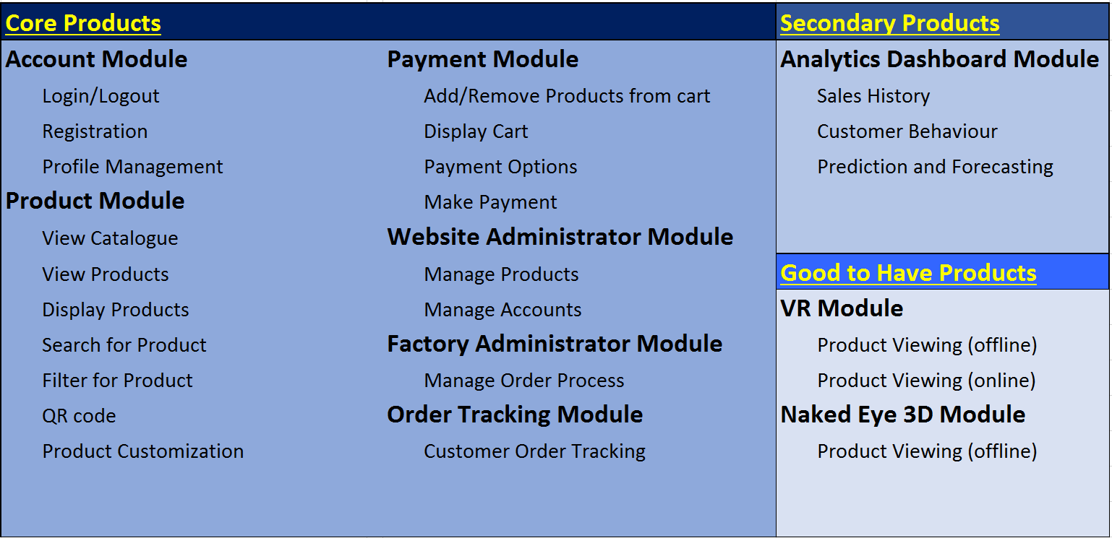

**Constraints:**   
Analytics dashboard should only be started once the IT solution is fully functional for all users.

**Assumptions**: -

**Project Plan**

This plan describes the resource, schedule and major risks. The plan provides a basic execution description of the project based on current knowledge of the project.

**Project milestone:**

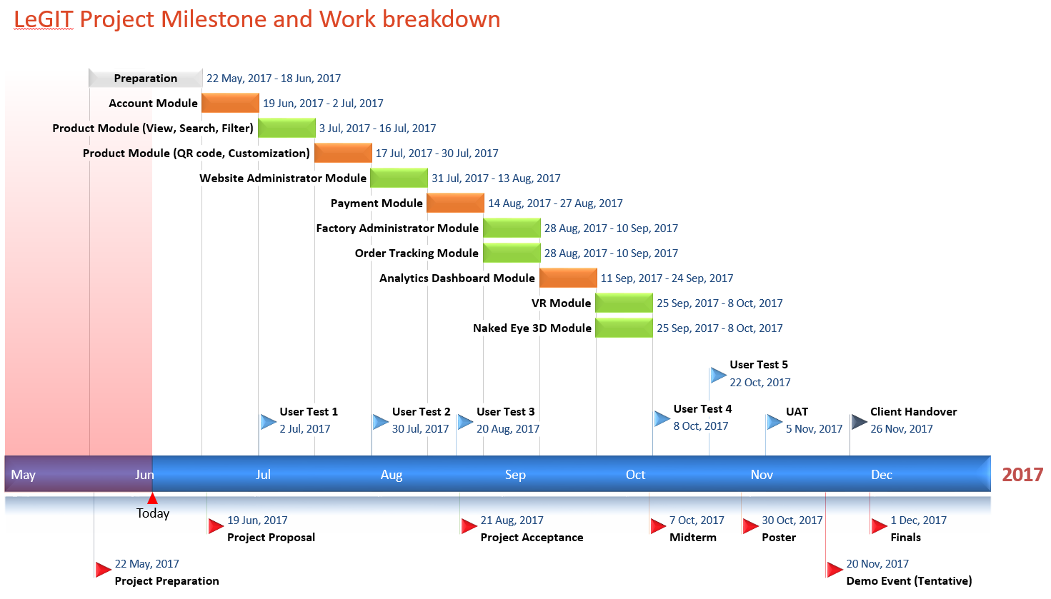

**Risks:**

|  |  |
| --- | --- |
| Risk | Mitigation |
| QR Code, VR, Naked Eye 3D technologies might not integrate well with developed IT solution | 1. Learning and research to be done extensively to identify possible compatibility issues  2. Develop the IT solution with preparation for integration with these 3 technologies in mind |
| Sponsor might be unavailable for  bi-weekly meeting | 1. Postpone meeting and meet contact whenever nearest time possible  2. Video conference meeting |
| Unforeseen commitments or events of group members   (E.g. Sickness, urgent family commitments, going on a holiday during term breaks, laptop not functioning) | 1. Review tasks and plans and make changes where possible.  2. Schedule tasks in buffer period if it is not possible to reschedule tasks to accommodate the delay.  3.  Alert client if some functions is not ready by planned time.  4. Last resort: Alert client if some functions need to be dropped. |

**Resource and reference:**

What do you need? Training on programming (list books, web pages, hardware, software, gadgets, contact, client time, tester time, supervisor time, training course, money, trips), etc.  Described the technology that you will be using (programming language, frameworks, APIs, platforms, OS, etc).

**Resources Needed** (to be provided by client):

Server: Amazon Web Service

**Resources Used:**

Framework: Angular

Programming: Java, Netbeans, Javascript, CSS, HTML

Database: MySQL

Training: Technologies required to implement QR code, VR viewing and Naked Eye 3D